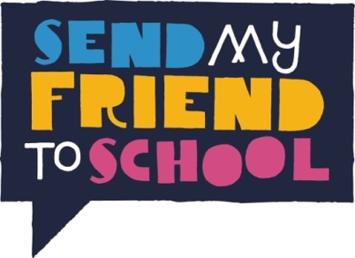
Apply now to be a 2018 Campaign Champion!

Applications must be made jointly by two students and one teacher and emailed to ellie.mcdonald@results.org.uk by the end of the day on 15th December 2017.

The Send My Friend to School campaign values diversity, equality and inclusion for persons working for and on behalf of the campaign. We strongly encourage applications from young people of any gender, disabled young people and young people of diverse cultural, ethnic, socio-economic and other distinctive backgrounds. If you need any additional support to complete the application form or attend the training, then please do get in touch.

Name, Address & Phone Number of School
Name of Applicant 1 (teacher)
Name & DOB of Applicant 2 (student)
Name & DOB of Applicant 3 (student)
Please indicate if any of the applicants have a disability and/ or accessibility requirements?
Please indicate if either/ both of the students receive pupil premium/low income?

Tell us a little bit about yourselves. What qualities would you bring to the campaign? (max 150 words per applicant)

Please answer the following questions jointly:
Why do you want to be Send My Friend to School Campaign Champions? (max 200 words)

Why is it important to you to be involved in campaigning to ensure that all children across the world get a quality education? (max 200 words)

What would you do if you were world leaders for the day? (max 200 words)

How would you encourage your school and wider community to get involved in the Send My Friend campaign? (max 200 words)

Please tick to confirm your application meets the following requirements:
- This is the only application from your school
- The two student applicants are in Year 9 or 10
- This application is from a UK State school
- If successful, applicants would be available for a video interview during w/c 15th Jan.
- If successful, applicants are able to attend UK residential training in from the afternoon of Friday 23rd – Sunday 25th March.
- If successful, applicants are able to attend a special event in parliament expected to take place on the 20th June (tbc).
- If successful, applicants are committed to campaigning on education throughout 2018 including attending at least the residential training, one campaign engagement and running at least one event in their school/community. We estimate this will take approximately one hour per week between March and November 2017.
- If successful, applicants will keep in regular contact with Send My Friend and respond to emails and phone calls promptly

Signed by:
Applicant 1 | Applicant 2 | Applicant 3 (teacher)
I have read the above requirements for Campaign Champions and confirm that _____________________________ School supports this application.

Leadership team member (to give approval)

