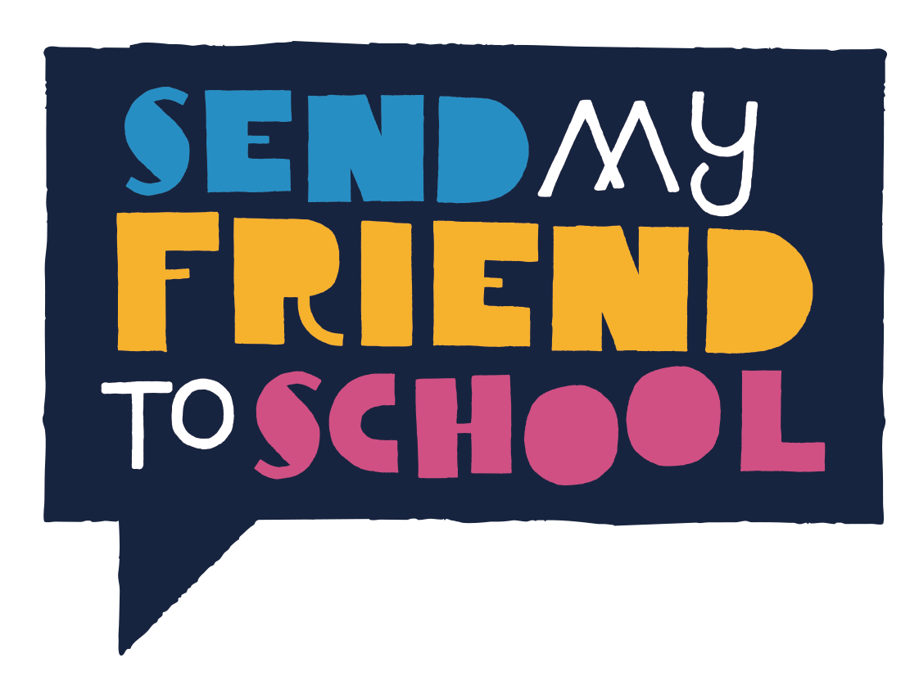
PRESS PACK

Get your school in the media!

If your school is taking part in Send My Friend to School, then spread the word by getting online and in the local papers. It’s a great way to amplify the campaign message and at the same time show your community what you’ve been doing!

Below are some top tips on using social media and the local papers as part of your campaigning. You can use the Send My Friend logos and images here to make the most of your press releases, displays, websites, blogs, newsletters and social media feeds and get the word out.

Social Media
Twitter

- Follow us on Twitter @sendmyfriend and we’ll make sure to follow you back.
- Tag @sendmyfriend and use the hashtag #missingpiece so that we can easily find your tweets - and we’ll retweet as many as we can!
- Spread the word about your school’s Send My Friend activities - include photos of events and classroom activities so everyone can see what you’ve been doing.
- Find the Twitter account for your local MP and connect to them. Why not take photos of the messages your students write on their paper jigsaw pieces and tweet them to your MP and to @sendmyfriend?

Here are some ideas for tweets:
Our students have been busy making jigsaw schools with @sendmyfriend to call on government to fix #missingpiece in global education crisis

Education is powerful & so are our students – that’s why they’re joining the @sendmyfriend call for more investment in global education.

We’re taking action with schools @sendmyfriend and thousands of schools all over the UK to call on the govt to invest in the power of education

263 mill children are missing out on school globally. That’s why we’re taking action w @sendmyfriend to call for quality education for all

Facebook

- Like us on Facebook at www.facebook.com/sendmyfriend and Like, Share or Comment on our posts!
- If you are posting on your Facebook page, don’t forget to tag us using @sendmyfriend
- Post about your Send My Friend activity, and try to include photos or videos of what you have been up to as these will show up more in people’s feeds.
- Encourage other people to share your posts with their friends, teachers and other schools!

Here are some ideas for Facebook posts:
We’re taking action with schools across the UK to call on the UK government to invest in the power of education across the world. Our students have even written their own messages to send to our MP as part of the @sendmyfriend campaign!

Around the world, 263 million children are missing out on school. That’s why our students are taking action as part of the @sendmyfriend campaign. You too can raise your voice for change!

Our students have been busy creating jigsaw piece schools including their own personal messages on why they think it’s so important that the UK invests in education for every child around the world. Take action with us as part of the @sendmyfriend campaign!

Local Press

Step 1 - Find out details of your local media. Your school marketing officer may have a list or you could find details on the internet. You could include local papers, regional BBC & independent radio stations and local magazines.
Step 2 - Adapt the below press releases and send. Add a time to the press release when photographers can come and take pictures of the most photogenic moment. Paste the press release directly into an email and send it out about 1-2 weeks in advance to the News Editor.
Step 3 - Follow up each contact. Phone them to check that they have received the press release and that the date is in their diary! If they haven’t, send it through again!
Step 4 - On the day create a good photo opportunity, such as a display of your school classroom jigsaws or a class picture with your MP. Make sure you take your own photos - If a newspaper can’t send a photographer, they may still print the story afterwards if you send them some good images. Find out who is the best photographer in school and be imaginative with the picture.

We would love to see how you get on – please scan in and send your press clippings to ema.jackson@results.org.uk
Template press release:
Please tailor the text marked in red with your event details.

[x MP] visits [x] school in [x area] to see pupils’ campaign to end to the global education crisis that’s keeping 263 million children out of school [OR] Pupils at [x] school in [x area] get creative to end to the global education crisis that’s keeping 263 million children out of school

Date of event: xxxxx
Time: xxxxx
School address: xxxxx
[x MP] is going back to school at [x school] on [x date at x time] to hear from pupils calling for increased investment to ensure every child across the world receives a quality education. Hundreds of MPs will be taking part in the Send My Friend to School campaign during 2017, which will involve thousands of young people across the UK.
[OR] Local pupils at [x school] are speaking out for the millions of children across the world who are missing out on getting an education. They are getting creative to support – alongside thousands of others – the Send My Friend to School campaign’s call for increased investment in the power of education.

World leaders have made clear a promise to ensure every child in the world gets a quality education by 2030. But a key piece of the puzzle is missing – the money to pay for this education – leaving the global picture with 263 million children missing out on school, and many of those in school not learning.

2017 is the year to change this education funding crisis - in the coming months world leaders will be pledging support to the Global Partnership for Education, the world’s joint fund for education. Students at [X School] want to ensure that the UK government pledges big and so have been getting creative to get their MP’s attention.

[Insert name of teacher] at [x School] said: [Please insert what you want to say about your pupils for e.g… “Class x/the whole school have been finding out about the limited resources preventing millions of children across the world from receiving a quality education and now they are so passionate about doing something change the situation.”

[Please insert what activities your school has done/will be doing when the MP comes in, for e.g…] “To get our MPs attention the children have created eye-catching paper jigsaw piece schools symbolising that there is a missing piece in the global education puzzle – the money to pay for good quality schooling. They decorated their paper jigsaw pieces with the elements they feel are most important for a quality education and have added their own messages about why they think the UK should invest in the power of education. They will be giving these to x MP and asking [her/him] to take the message to the government.”

Ema Jackson, Campaigns Manager for the Send My Friend to School campaign said: “Education is powerful and transformative, and a basic human right for all children but despite this, 236 million receive no education and many more are in school but not learning. The world is experiencing an urgent education crisis. So I am delighted that pupils at x school are engaging with x MP to demand the UK invests in the future of the world. They are joining thousands of young people across the country - we are expecting MPs to be inundated with thousands of these creative jigsaw pieces covered with important messages! We hope this will push them in to action.”

All schools are invited to get involved with the Send My Friend campaign - visit sendmyfriend.org for a free teaching resource pack with everything needed to take action on this important issue.

Notes to Editors:

For more information, please contact:
Ema Jackson, Global Campaign for Education UK, ema.jackson@results.org.uk
020 7793 3970

1. The Send My Friend to School campaign is a schools based campaign organised by the Global Campaign for Education UK. www.sendmyfriend.org Twitter: @sendmyfriend

2. Key facts
- There are 263 million children and young people out of school: 61 million primary school age; 60 million lower secondary school age and 142 million upper secondary school age
- In the world’s poorest countries, only half of primary school aged children & little more than a quarter of secondary school age children are learning basic primary and secondary level skills.
- $1 invested in an additional year of school generates $10 in benefits in the world’s poorest countries.
- 25 million children will never even begin primary school.
- Aid needs to increase at least six-fold to fill the $39billion annual financing gap, but in 2014 aid levels were 7% lower than in 2010.

3. The Global Campaign For Education UK (GCE–UK) is a civil society coalition made up of a wide range of members from international development NGOs to teachers’ unions and charities, all working towards the common goal of achieving education for all. The current GCE-UK members are listed here.

