Consequence wheels activity sheet: KS2-3
Read Abdi’s story. What happens when Abdi has seizures?
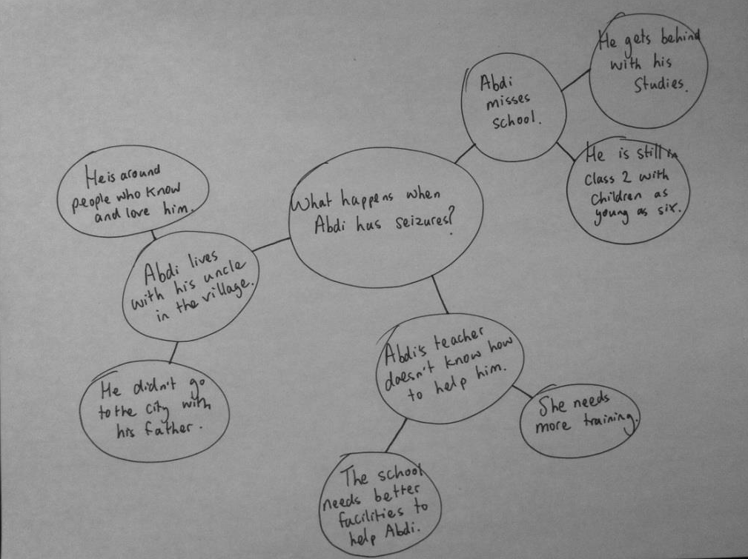
Here’s an example:

Draw your own wheel. Write a question in the middle circle, e.g. What happened when Tasui dropped out of school? What happened when Emma got involved in Send My Friend to School? What might happen if Linh has a wheelchair? What might happen if I get involved with Send My Friend to School? Colour code circles to show whether the consequence is positive or negative, or both.

This project is funded
by the European Union.

